VBA Challenge Homework Screen Capture

**2016**

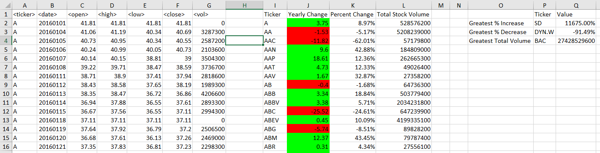

**2015**

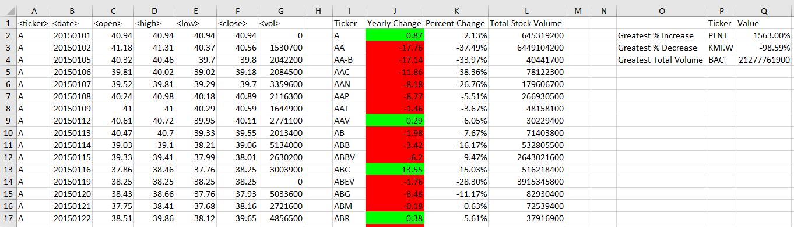

**2014**

